1. **Types of success along with diagram.**

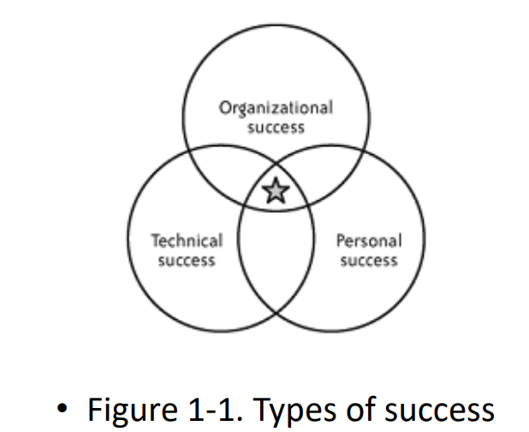

* All three types of success are important (see Figure 1-1).
* Without personal success, you’ll have trouble motivating yourself and employees.
* Without technical success, your source code will eventually collapse under its own weight.
* Without organizational success, your team may find that they’re no longer wanted in the company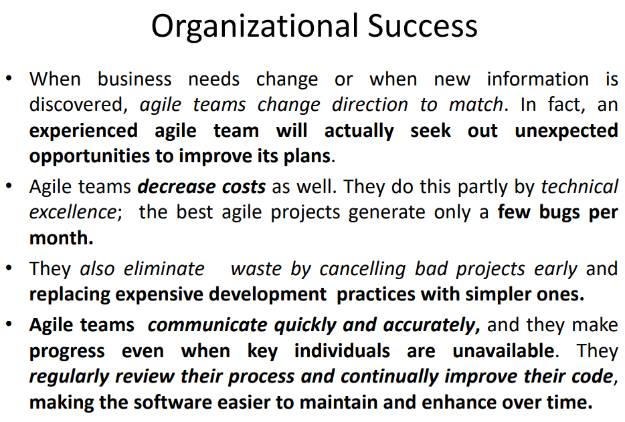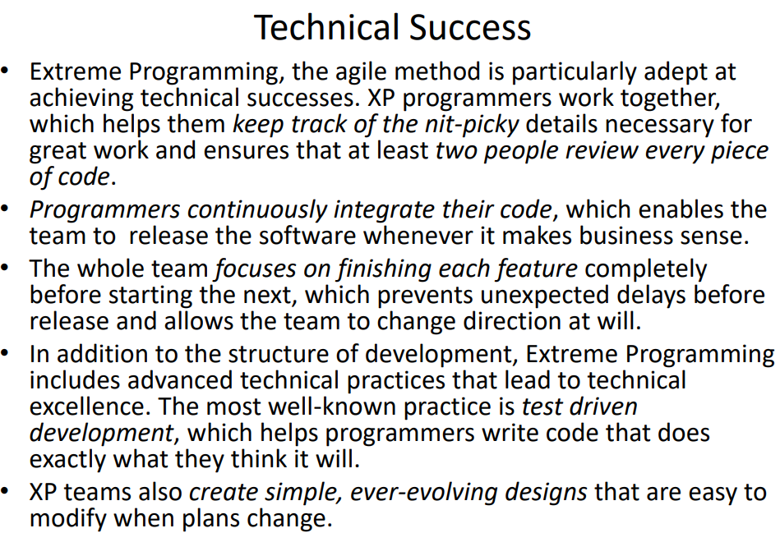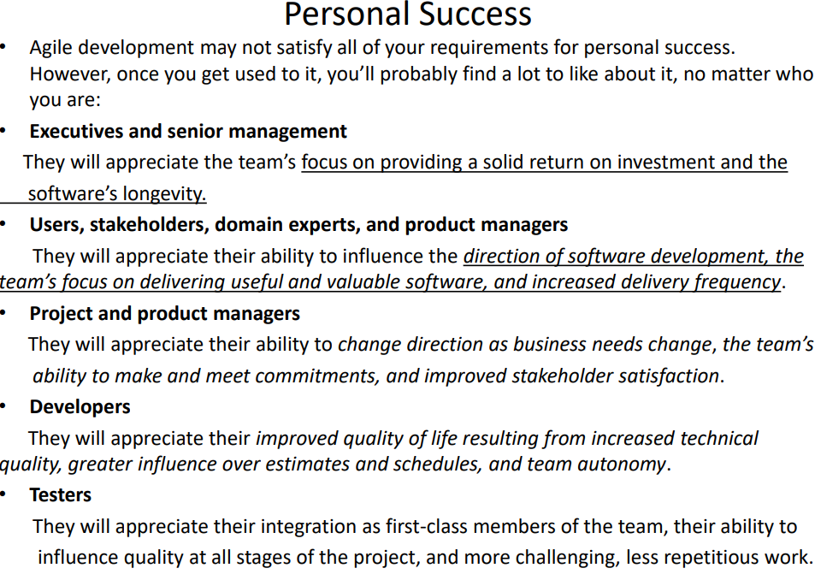

1. **Agile values and principles**

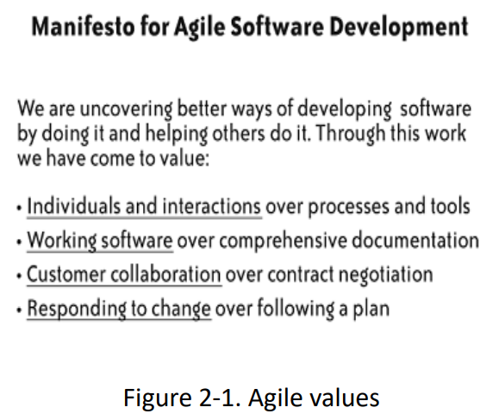

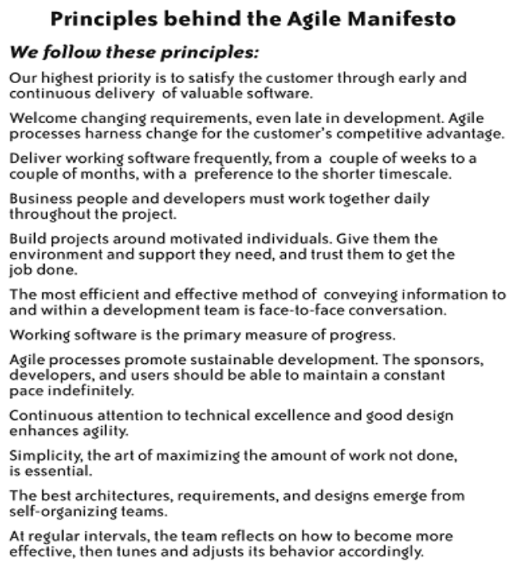

1. **Traditional vs XP Lifecycle**

**4. XP Whole Team**

**5. Team Size**

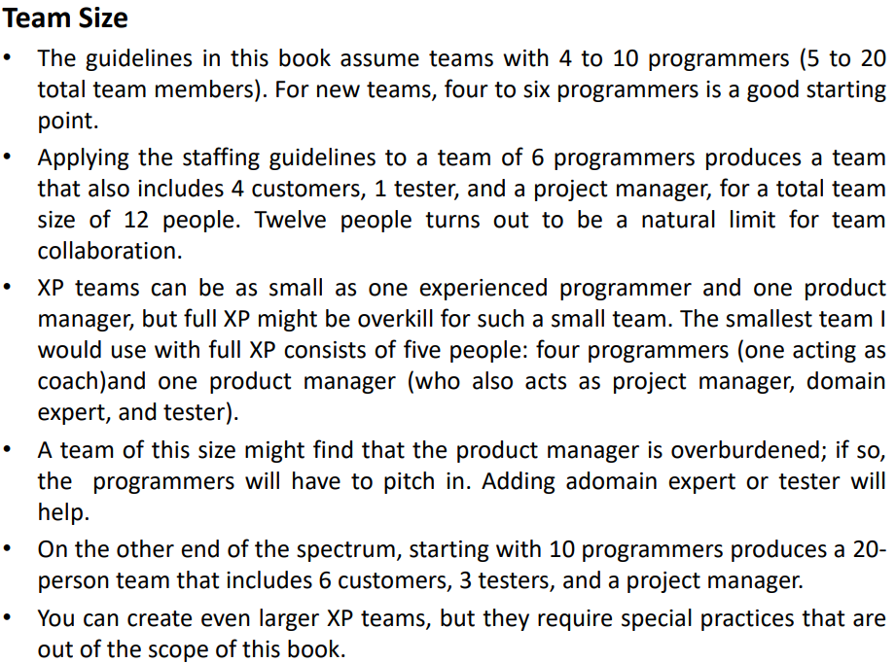

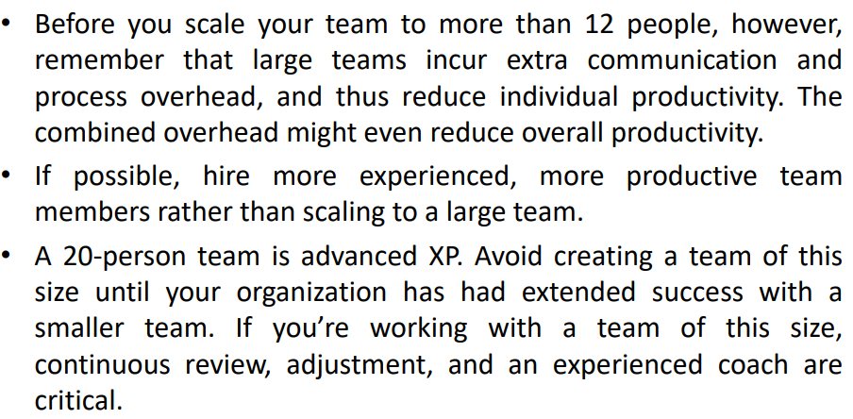

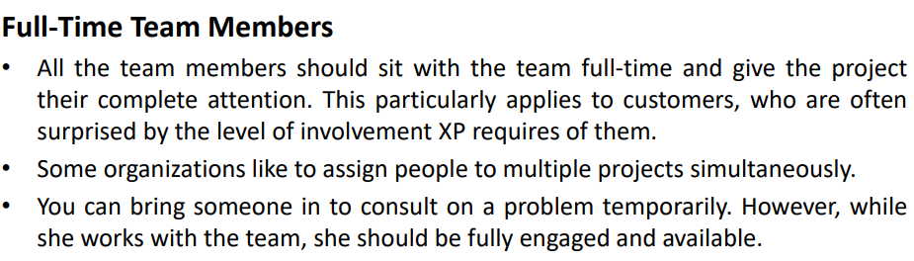

**6. Technical Debt, Time-boxing, velocity,**

TECHNICAL DEBT  
Imagine a customer rushing down the hallway to your desk. “It’s a bug!” she cries, out of breath. “We have to fix it now.” You can think of two solutions: the right way and the fast way. You just know she’ll watch over your shoulder until you fix it. So you choose the fast way, ignoring the little itchy feeling that you’re making the code a bit messier. Technical debt is the total amount of less-than-perfect design and implementation decisions in your project. This includes quick and dirty hacks intended just to get something working right now! and design decisions that may no longer apply due to business changes. Technical debt can even come from development practices such as an unwieldy build process or incomplete test coverage. These dark corners of poor formatting, unintelligible control flow, and insufficient testing breed bugs. The bill for this debt often comes in the form of higher maintenance costs. There may not be a single lump sum to pay, but simple tasks that ought to take minutes may stretch into hours or afternoons. Left unchecked, technical debt grows to overwhelm (have a strong emotional effect) software projects. Software costs millions of dollars to develop, and even small projects cost hundreds of thousands. It’s foolish to throw away that investment and rewrite the software, but it happens all the time. Why? Unchecked technical debt makes the software more expensive to modify than to re-implement. What a waste. XP takes a fanatical approach to technical debt. The key to managing it is to be constantly vigilant. Avoid shortcuts, use simple design, refactor relentlessly(continuosly) . in short, apply XP’s development practices

TIMEBOXING   
Some activities invariably stretch to fill the available time. There’s always a bit more polish you can put on a program or a bit more design you can discuss in a meeting Recognizing the point at which you have enough information is not easy. If you use timeboxing, you set aside a specific block of time for your research or discussion and stop when your time is up, regardless of your progress. This is both difficult and valuable. It’s difficult to stop working on a problem when the solution may be seconds away. Timeboxing meetings, for example, can reduce wasted discussion

VELOCITY   
In well-designed systems, programmer estimates of effort tend to be consistent but not accurate. Programmers also experience interruptions that prevent effort estimates from corresponding to calendar time. Velocity is a simple way of mapping estimates to the calendar. It’s the total of the estimates for the stories finished in an iteration. In general, the team should be able to achieve the same velocity in every iteration. This allows the team to make iteration commitments and predict release dates. The units measured are deliberately vague(indefinite); velocity is a technique for converting effort estimates to calendar time and has no relation to productivity.

**7. For Adopting XP Prerequisites and Recommendations**

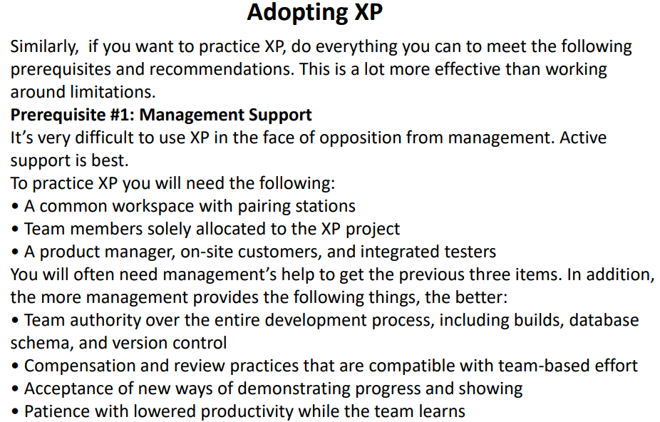

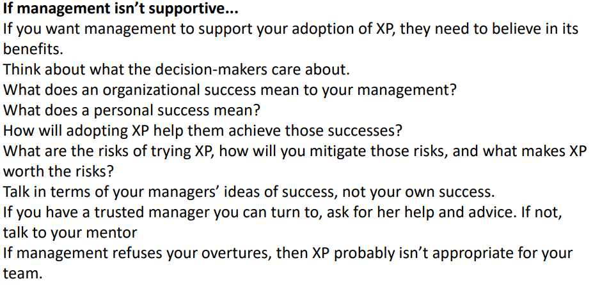

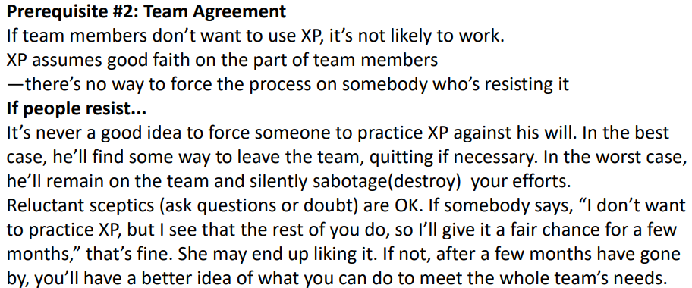

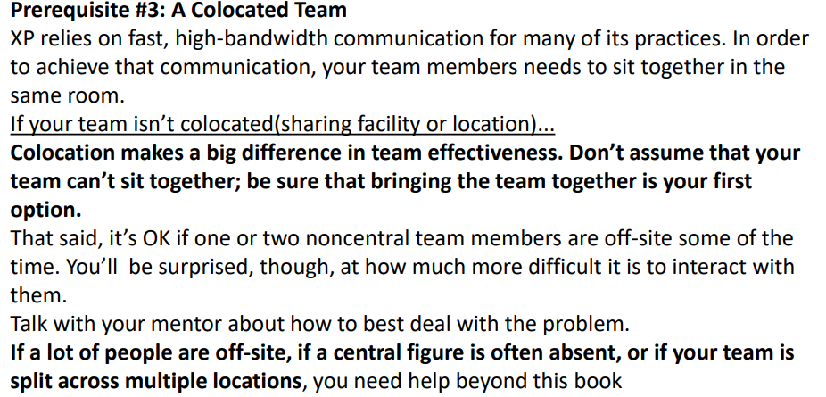

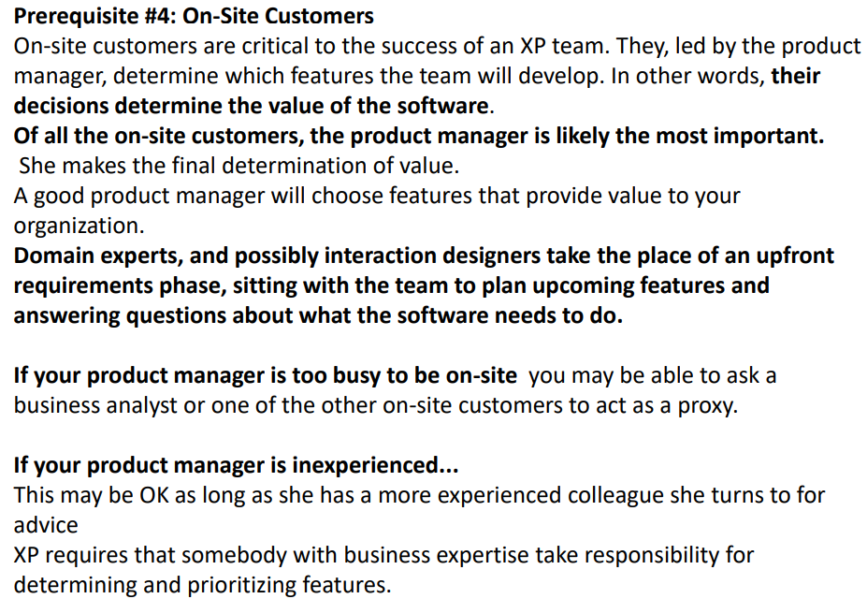

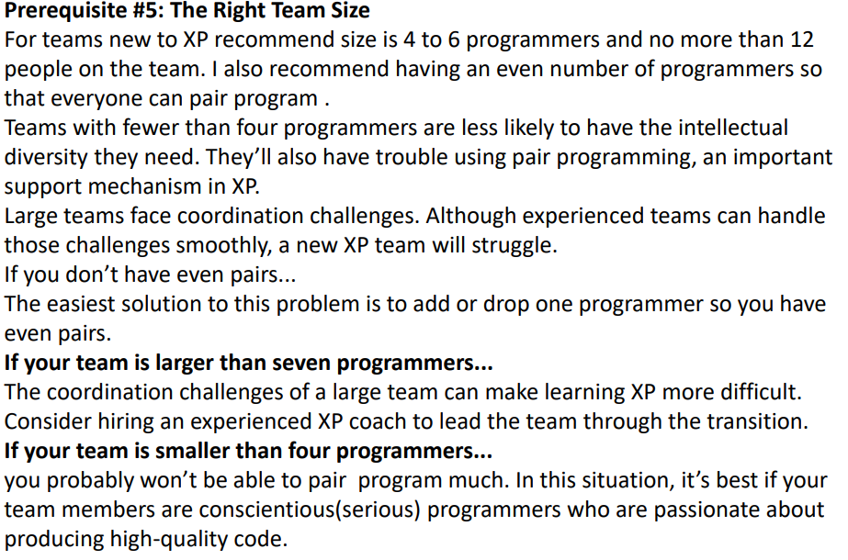

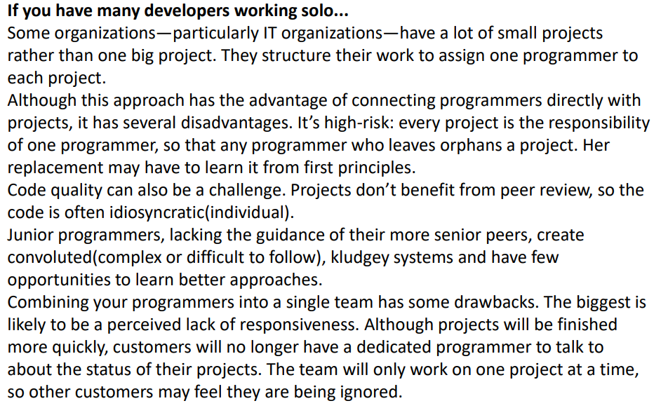

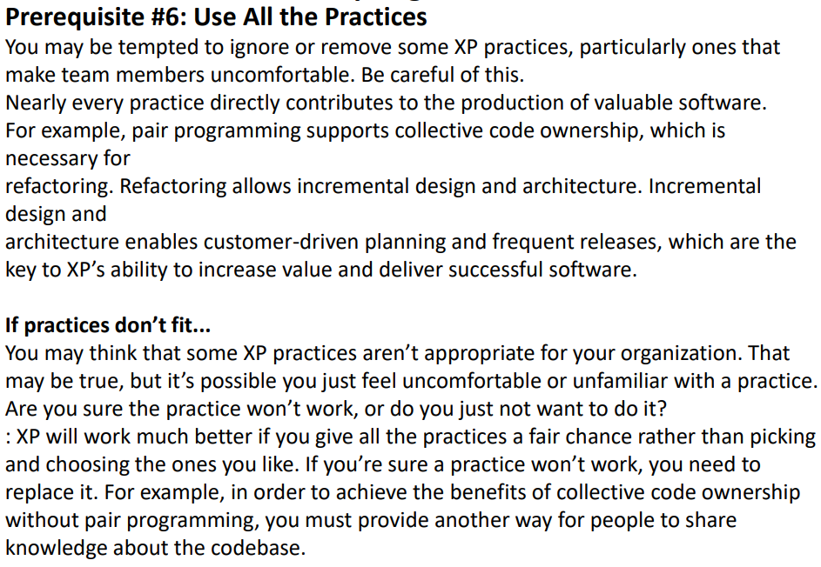

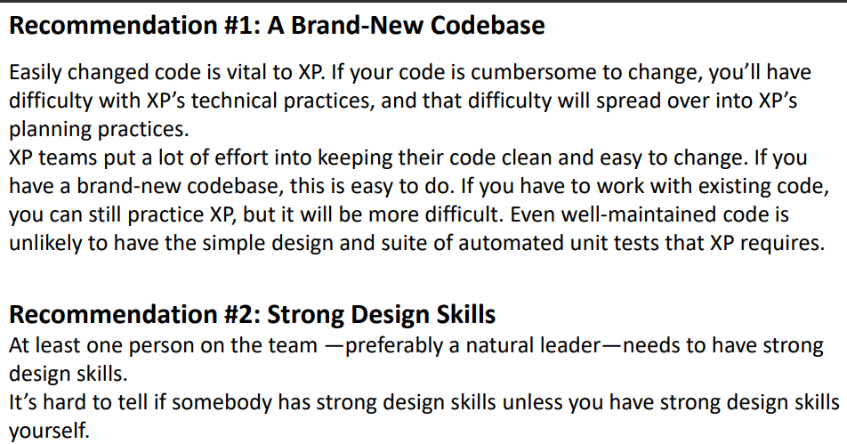

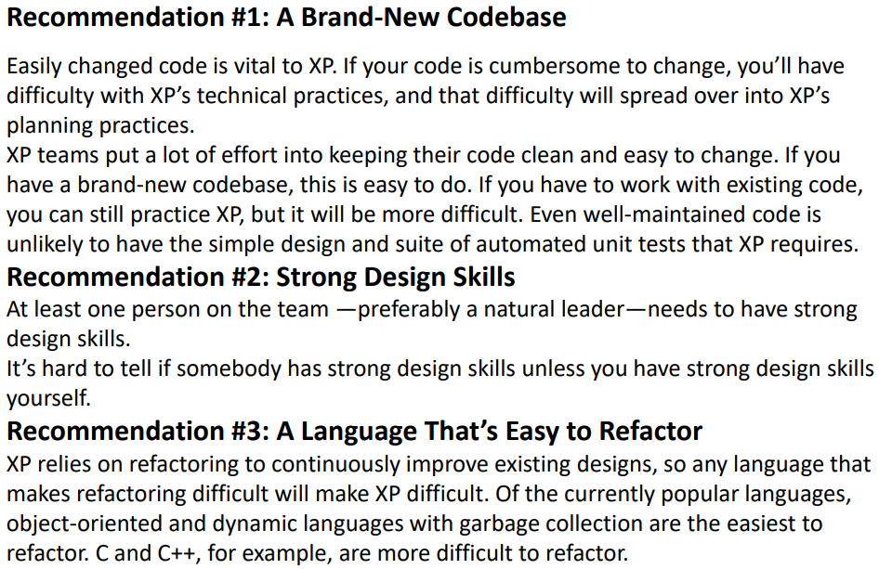

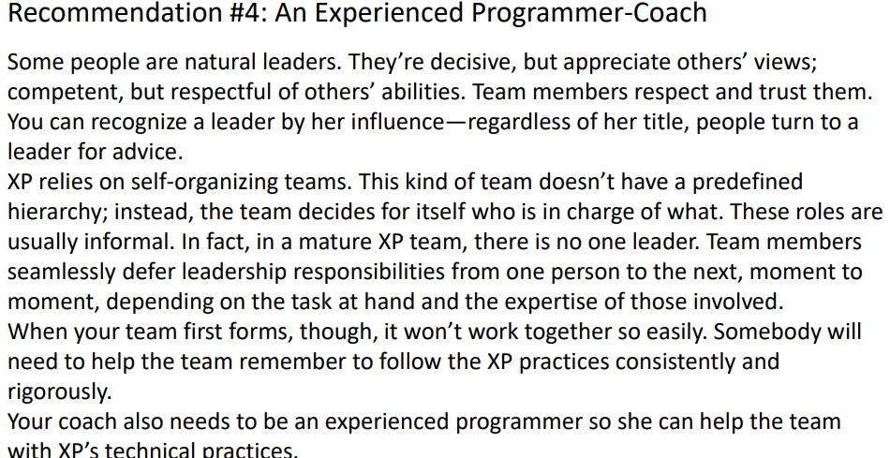

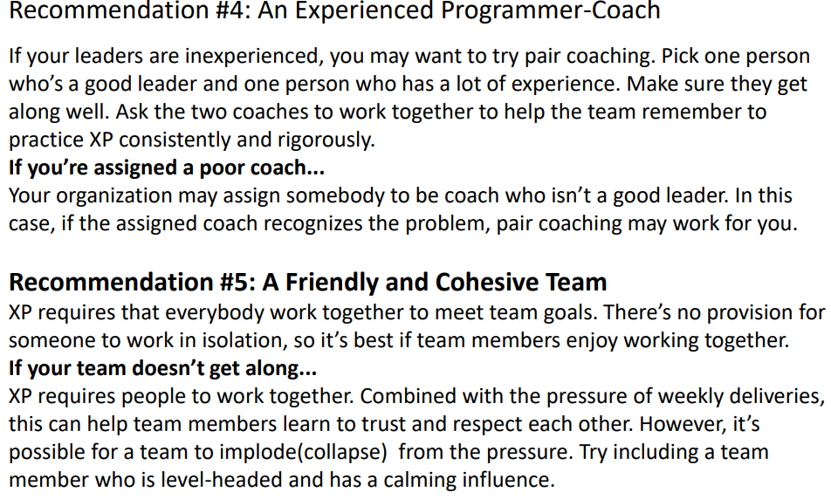

**8. Why Pair and how to Pair, Pairing Tips, Challenges,**

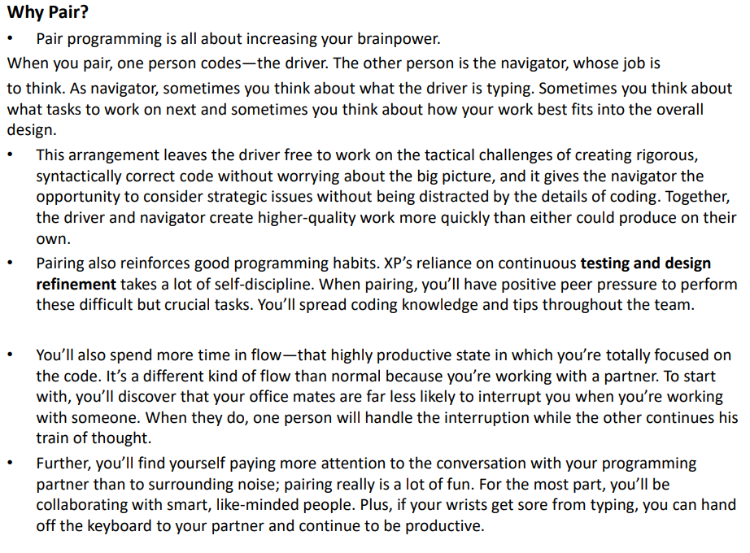

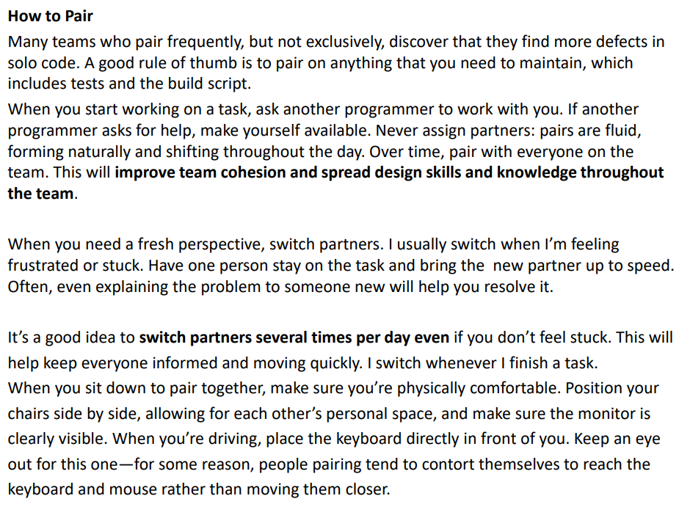

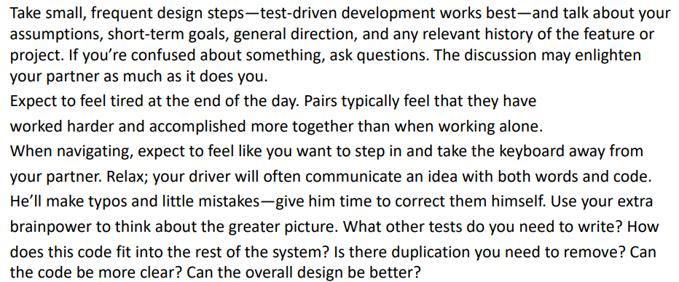

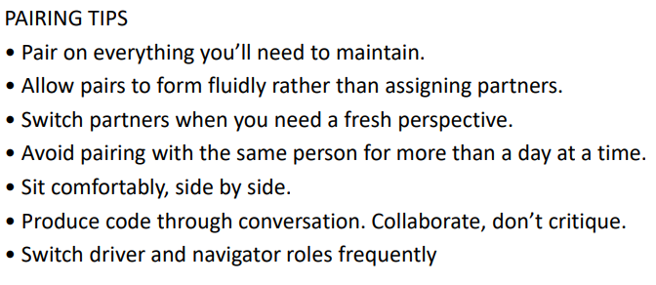

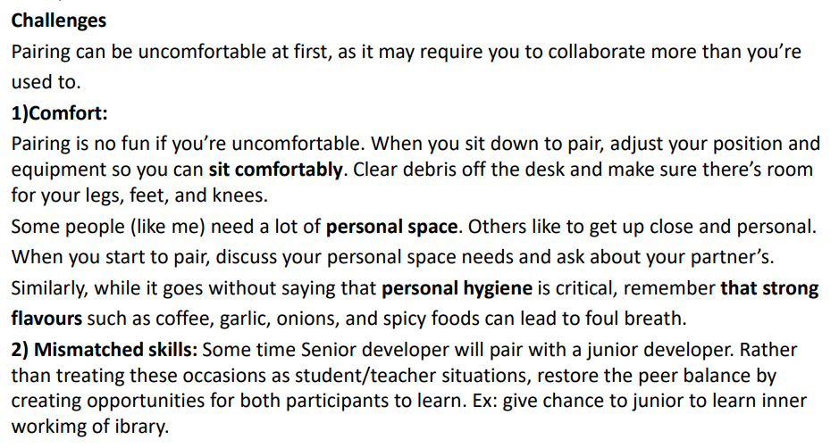

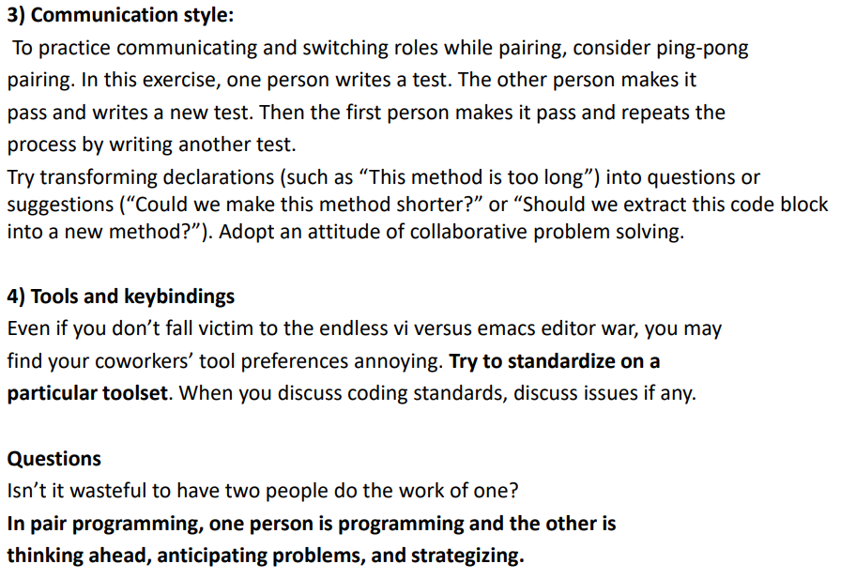

**9. Explanation of Root-Cause Analysis: How to find and fix these, When Not to Fix the Root Cause**

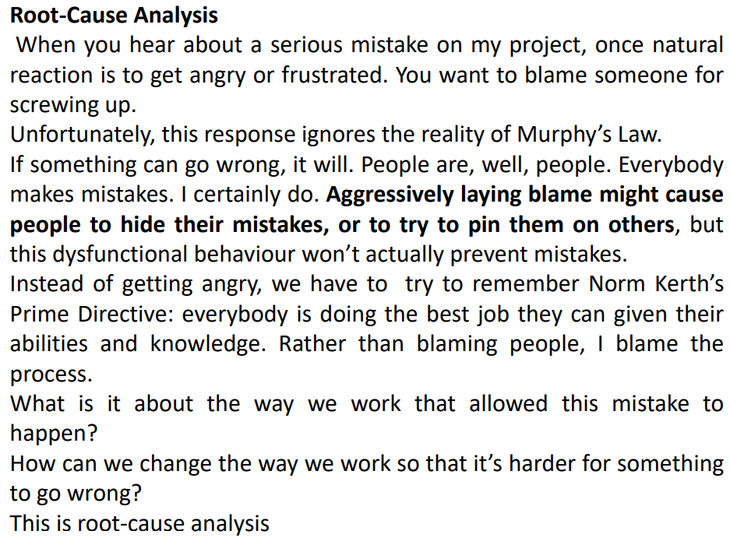

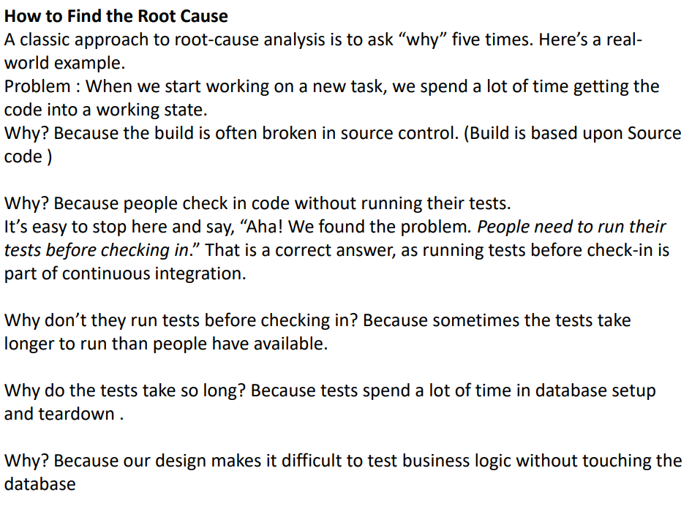

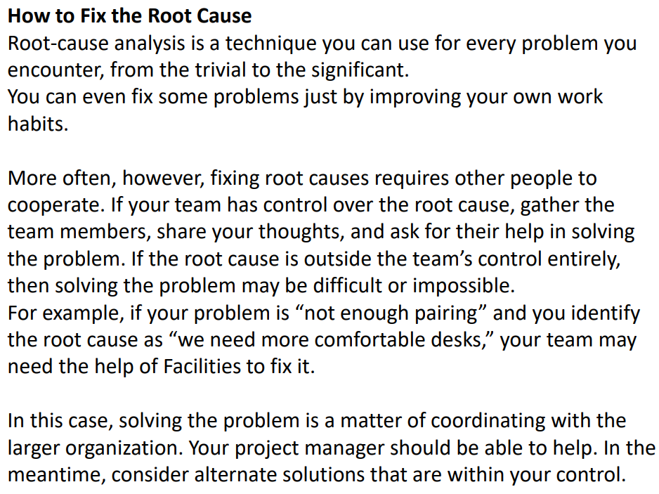

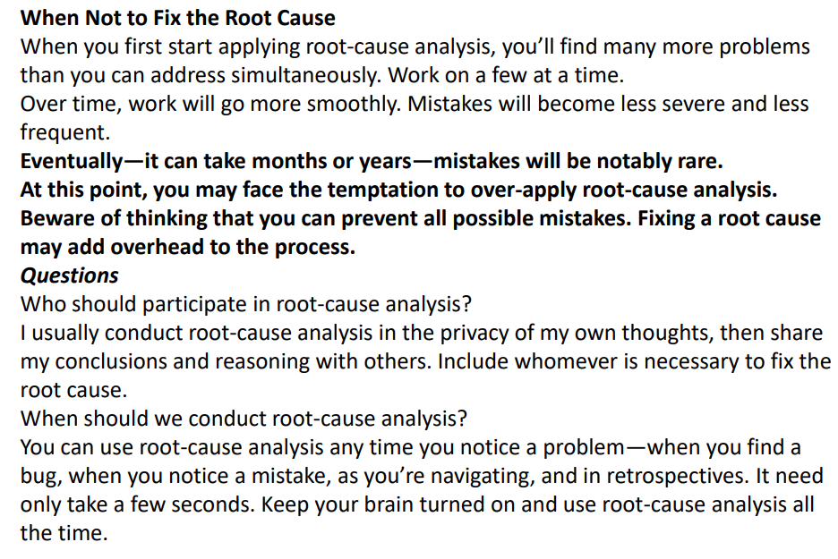

**10. Types of Retrospectives**

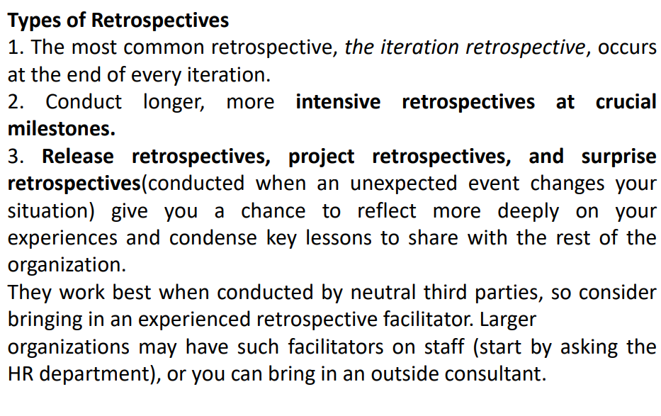

**11. How to Conduct an Iteration Retrospective?**

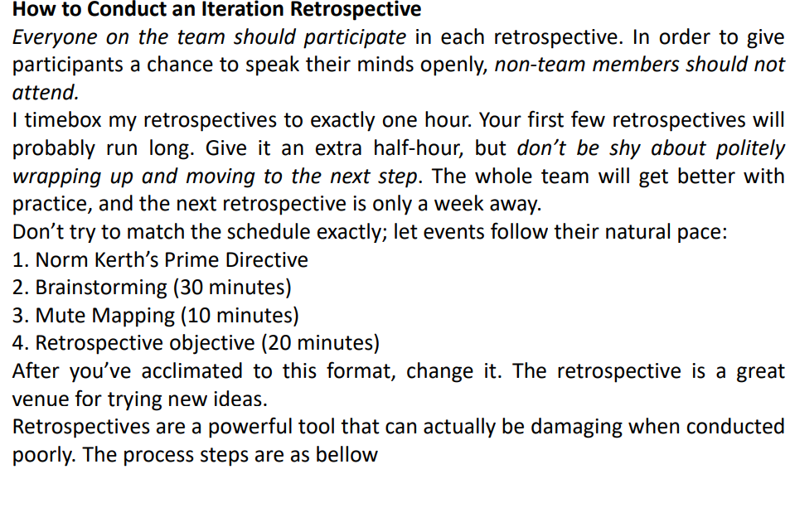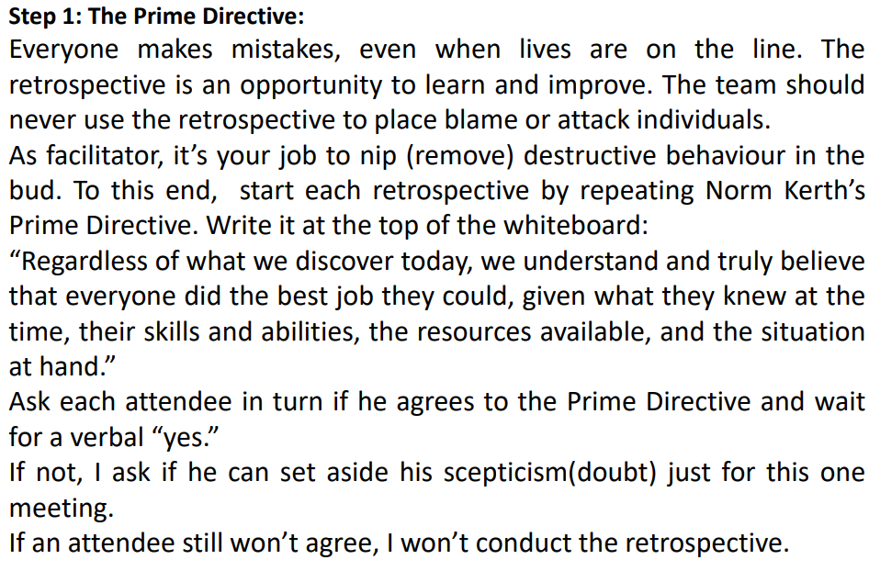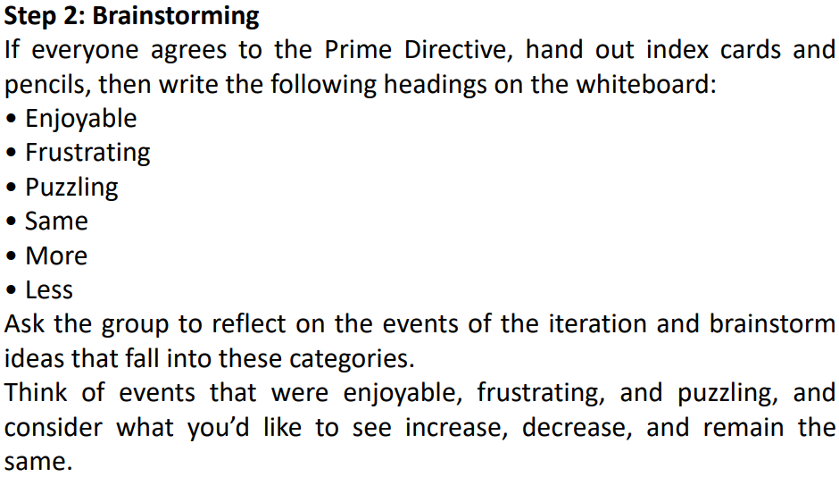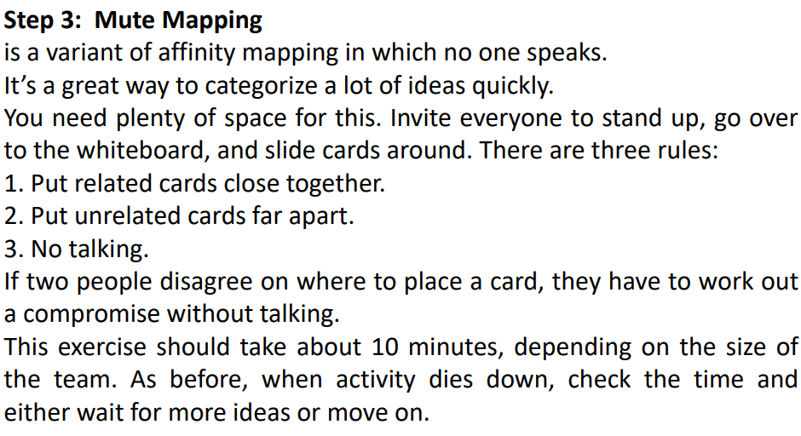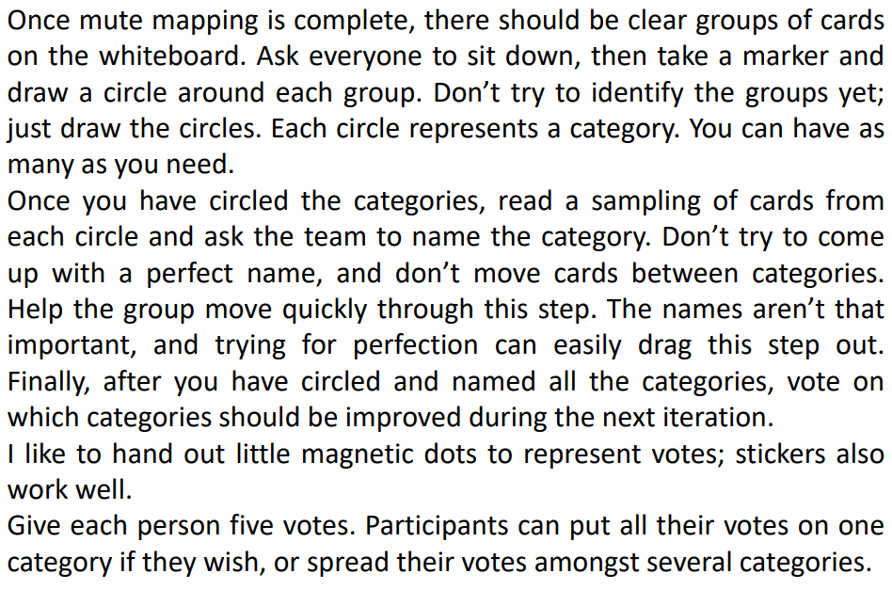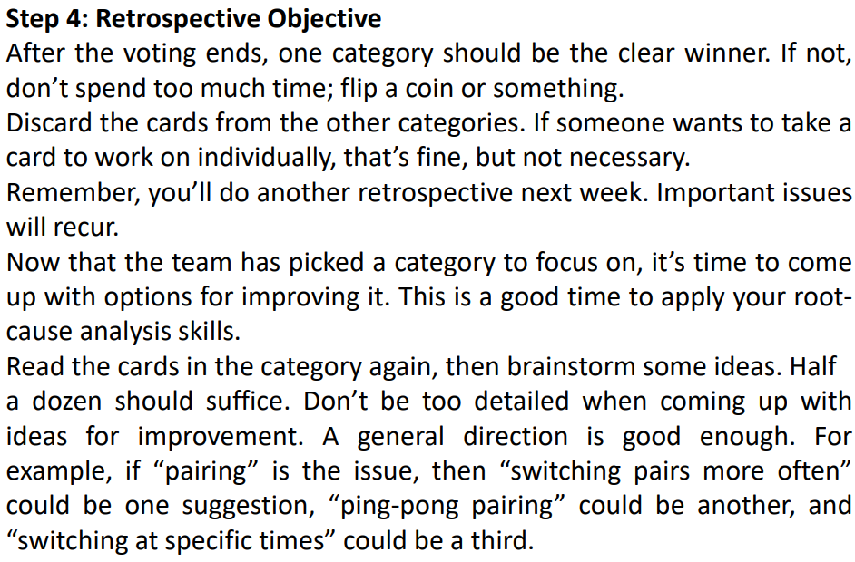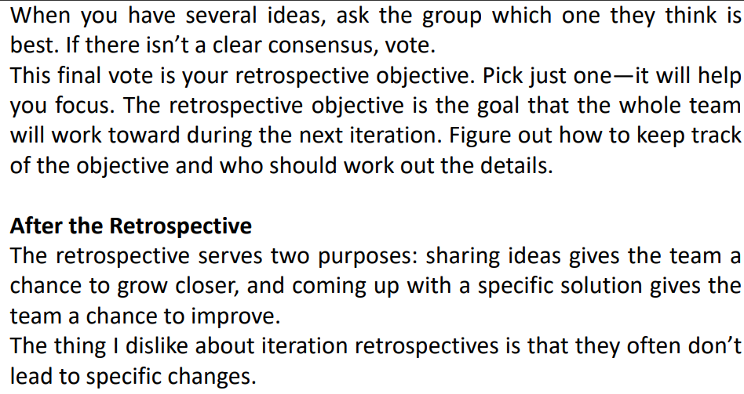

**12. Questions that could arise during Iteration Retrospective**

What if management isn’t committed to making things better? Although some ideas may require the assistance of others, if those people can’t or won’t help, refocus your ideas to what you can do. The retrospective is an opportunity for you to decide, as a team, how to improve your own process, not the processes of others. Your project manager may be able to help convey your needs to management and other groups.

Despite my best efforts as facilitator, our retrospectives always degenerate into blaming and arguing. What can I do? This is a tough situation, and there may not be anything you can do. If there are just one or two people who like to place blame, try talking to them alone beforehand. Describe what you see happening and your concern that it’s disrupting the retrospective. Rather than adopting a parental attitude, ask for their help in solving the problem and be open to their concerns.

If a few people constantly argue with each other, talk to them together. Explain that you’re concerned their arguing is making other people uncomfortable. Again, ask for their help. If the problem is widespread across the group, the same approach— talking about it—applies. This time, hold the discussion as part of the retrospective, or even in place of it. Share what you’ve observed, and ask the group for their observations and ideas about how to solve the problem If all else fails, you may need to stop holding retrospectives for a while. Consider bringing an organizational development (OD) expert to facilitate your next retrospective.

We come up with good retrospective objectives, but then nothing happens. What are we doing wrong? Your ideas may be too big. Remember, you only have one week, and you have to do your other work, too. Try making plans that are smaller scale—perhaps a few hours of work—and follow up every day. Finally, it’s possible that the team doesn’t feel like they truly have a voice in the retrospective. Take an honest look at the way you conduct it. Are you leading the team by the nose rather than facilitating? Consider having someone else facilitate the next retrospective.

Some people won’t speak up in the retrospective. How can I encourage them to participate? It’s possible they’re just shy. It’s not necessary for everyone to participate all the time. Waiting for a verbal response to the Prime Directive can help break the ice. On the other hand, they may have something they want to say but don’t feel safe doing it. You can also try talking with them individually outside of the retrospective.

One group of people (such as testers) always gets outvoted in the retrospective. How can we meet their needs, too? Over time, every major issue will get its fair share of attention. One team in my experience had a few testers that felt their issue was being ignored. A month later, after the team had addressed another issue, the testers’ concern was on the top of everyone’s list. If time doesn’t solve the problem—and be patient to start—you can use weighted dot voting, in which some people get more dot votes than others. If you can do this without recrimination, it may be a good way to level the playing field.

Another option is for one group to pick a different retrospective objective to focus on in addition to the general retrospective objective.

Our retrospectives always take too long. How can we go faster? It’s OK to be decisive about wrapping things up and moving on. There’s always next week. If the group is taking a long time brainstorming ideas or mute mapping, you might say something like, “OK, we’re running out of time. Take two minutes to write down your final thoughts (or make final changes) and then we’ll move on.”

The retrospective takes so much time. Can we do it less often? It depends on how much your process needs improvement. An established team may not need as many iteration retrospectives as a new team. I would continue to conduct retrospectives at least every other week. If you feel that your retrospective isn’t accomplishing much, perhaps the real problem is that you need a change of pace. Try a different approach

**13. COLLABORATING” MINI-ÉTUDE**

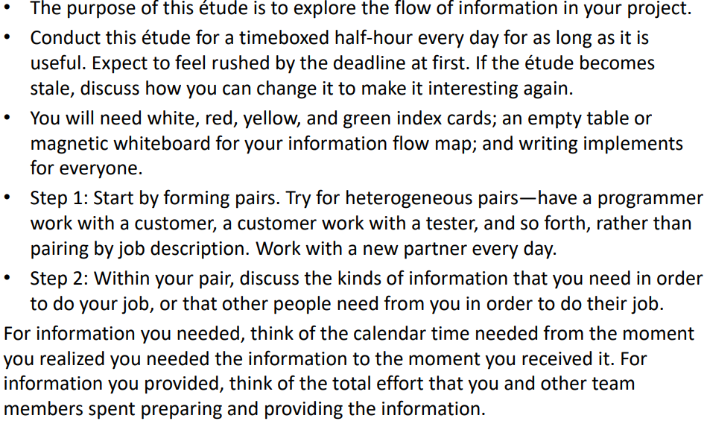

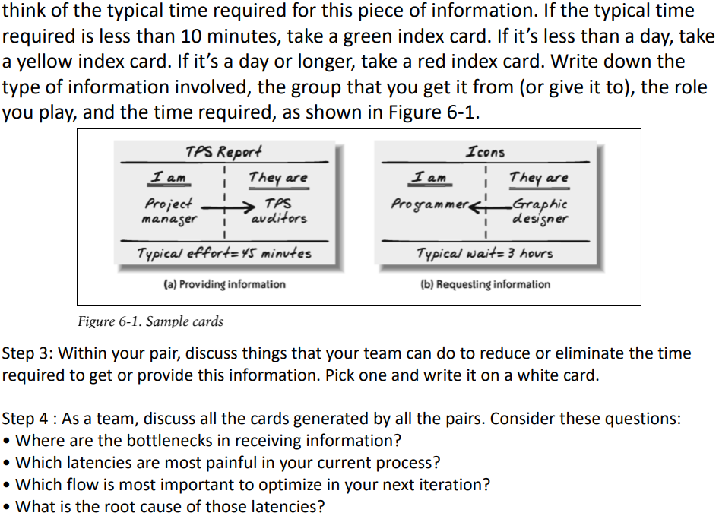

**14. Trust and some strategies for generating trust in your XP team**

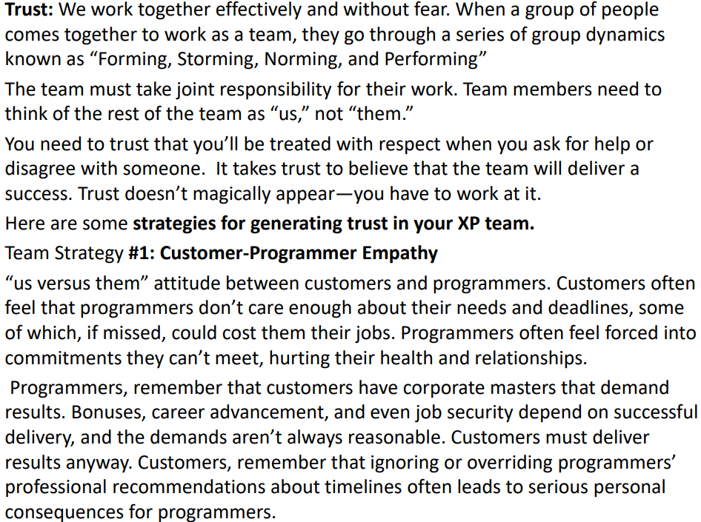

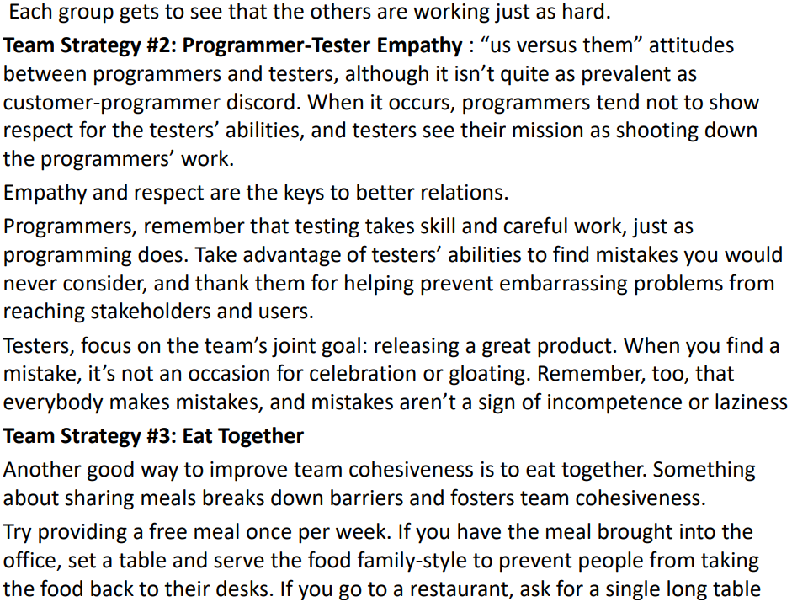

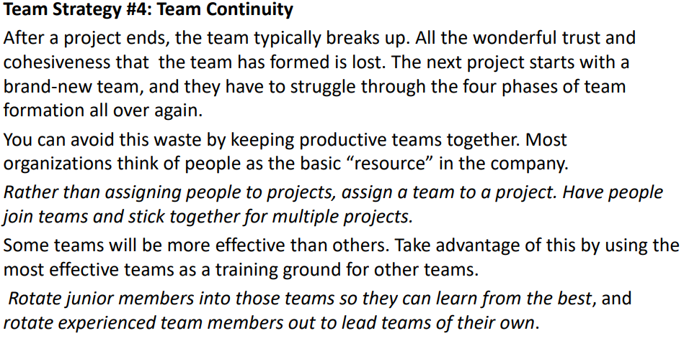

**15. Organizational Strategy**

